Grant & Aid: Getting Started
On any device, Go to: https://online.factsmgt.com/aid
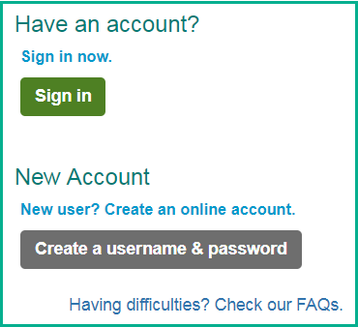
First:
Sign in with your existing FACTS account if you are a returning family, or have set up a FACTS account previously for another school. This is different from your Family Portal (ParentsWeb) login if your school uses FACTS SIS.
If this your first time with FACTS Grant & Aid, click Create an Account.
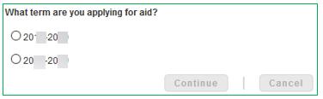
Next: Select the school year that you are applying for. Click ‘Continue’
Click Begin Application:

Select the school(s) & organizations you are applying to:
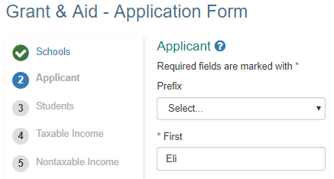
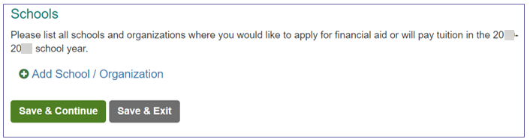
You’re on your way…
Click save & continue and you will move through each section of the application. You will be given an opportunity to review your answers before you submit your application and pay the application fee.

Don’t forget to upload your documents!
After you submit your application, the application summary will display the documents you need to upload to complete your application.

