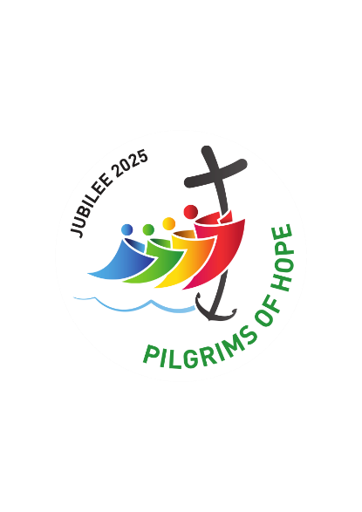
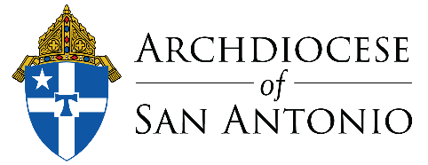

Bulletin and Pulpit Announcements

Our Parish/School Designated as a Jubilee Pilgrimage Site
We are honored and blessed to announce that [Parish/School Name] has been designated as an official Archdiocesan Pilgrimage Site for the Jubilee Year 2025! As part of this extraordinary time of grace and renewal, we joyfully invite all the faithful from across the Archdiocese of San Antonio to visit our parish and experience the spiritual blessings of this holy year.

We look forward to welcoming individuals, families, and groups from all over the Archdiocese as we journey together in faith during this upcoming year. Our schedule for Masses, reconciliation, and adoration, as well as information about special events and liturgies, will be posted on our website and available in the parish office. Let us celebrate the Jubilee Year 2025 with open hearts, embracing the spiritual gifts and opportunities that God is offering us. May this pilgrimage be a source of grace, renewal, and deeper communion with our Lord.

