Social Media Post 1 (generic)
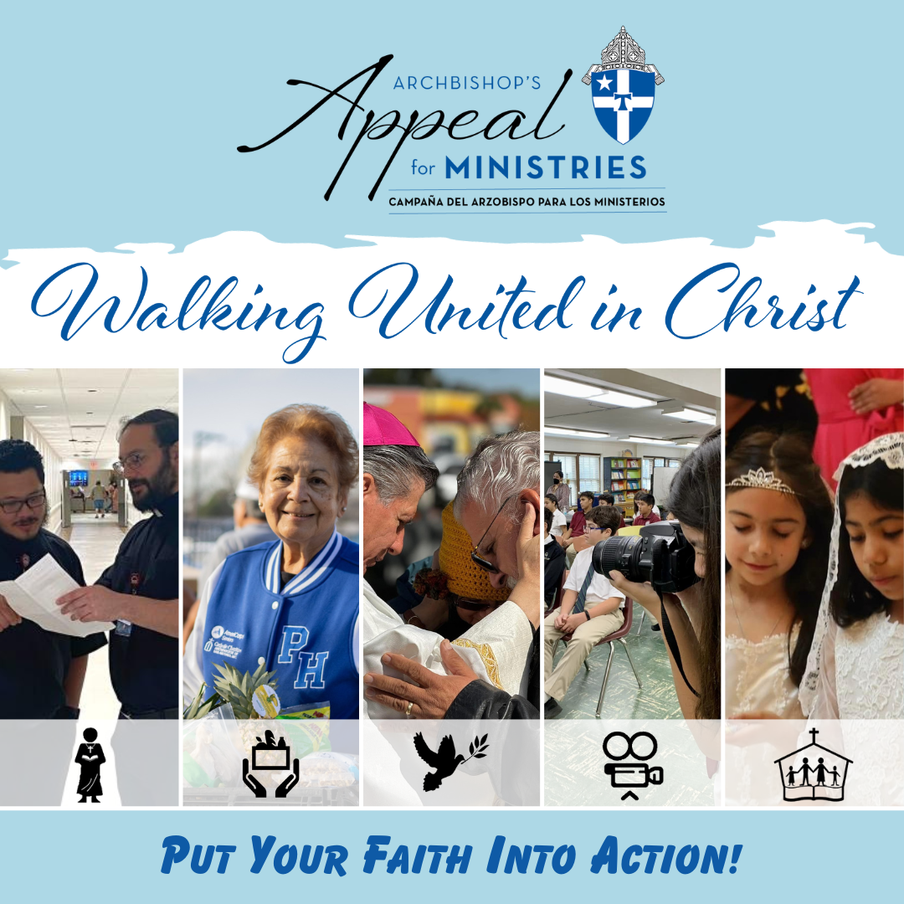
Caption (Facebook, Instagram, linkedin): With just ONE gift to the Archbishop’s Appeal for Ministries you can support over thirty ministries and charities in the Archdiocese of San Antonio! This includes San Antonio Vocations, Social Services, Pastoral Ministries, Catholic Communications, and Catholic Education!
Don’t delay, give to your local Catholic community TODAY!
archsa.org/archbishops-appeal/
#ArchbishopsAppealForMinistries #AAFM #PutYourFaithIntoAction

Twitter Caption: Just ONE gift to the Archbishop’s Appeal for Ministries you can support over 30 ministries and charities in the Archdiocese of San Antonio!
Don’t delay, give to your local Catholic community TODAY!
archsa.org/archbishops-appeal/
#AAFM
Social Media Post 2 (parish focused)
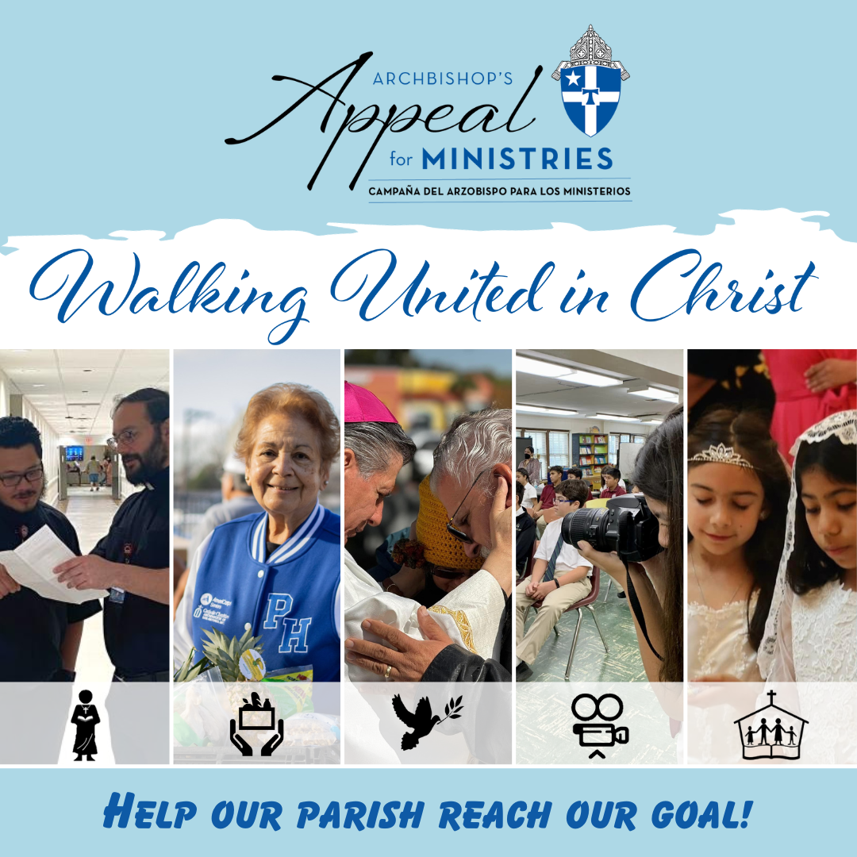
Caption (Facebook, Instagram, LinkedIn): Our Parish needs your help!
With just ONE gift to the Archbishop’s Appeal for Ministries you can support over thirty ministries and charities in the Archdiocese of San Antonio! This includes San Antonio Vocations, Social Services, Pastoral Ministries, Catholic Communications, and Catholic Education!
AND if we surpass our goal, our parish will start to receive some money back! Don’t delay, give to your local Catholic community TODAY!
Giving Link
#ArchbishopsAppealForMinistries #AAFM #PutYourFaithIntoAction

Twitter Caption: Just ONE gift to the Archbishop’s Appeal for Ministries you can support over 30 ministries and charities in the Archdiocese of San Antonio!
Don’t delay, help our parish reach our goal today!
archsa.org/archbishops-appeal/
#AAFM

