AAFM 2024
BROCHURE COPY
SECTION 4

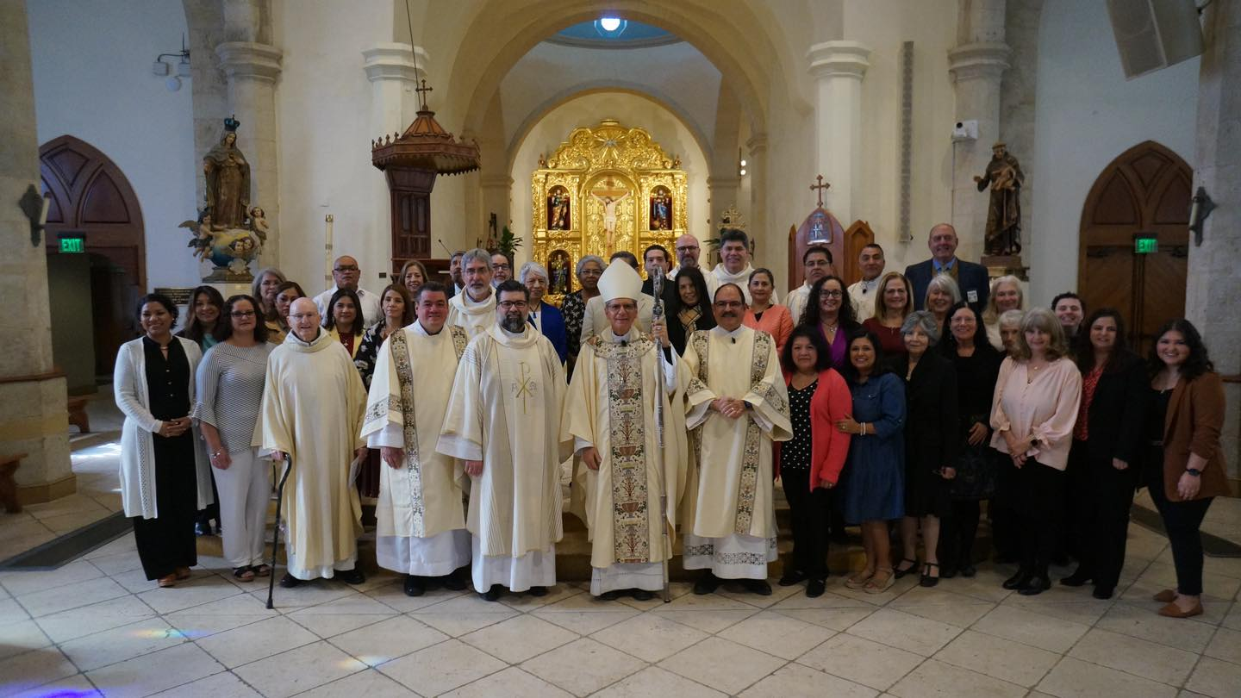
Prayer for a successful Appeal

More numerous than the stars in the sky
are your blessings, O Good and Gracious God.

You have called us to walk with you by caring for others
with our words and actions.

Strengthen our faith and open our hearts so that we may assist
our brothers and sisters who walk alongside us.

Help us to comprehend the difference we can make,
the love we can share and the lives we can bring to You.

We pray that your grace, O Lord, will lead us
to be your loving heart and hands.

Amen.

