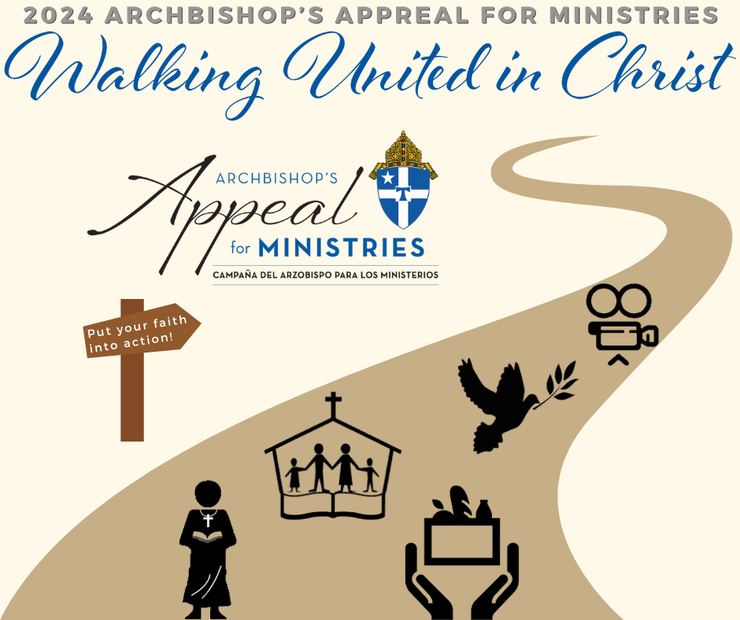

Possible Captions:
- The 2024 Archbishop’s Appeal for Ministries is here, and we need your help to reach our parish’s goal! Start Walking United in Christ and set up your gift today😄
We appreciate all your efforts👏
Set up your gift online: https://archsa.org/aafm_giveasa
#AAFM #WalkingUnitedinChrist #putyourfaithintoaction #giveback

- Put your faith into action by supporting the Archbishop’s Appeal for Ministries! All your gifts go towards helping the ministries continuing to do good in our community. You can make a difference not only at our parish but in the Archdiocese of San Antonio🙌
Set up your gift online: https://archsa.org/aafm_giveasa
#AAFM #WalkingUnitedinChrist #putyourfaithintoaction #giveback

More options below
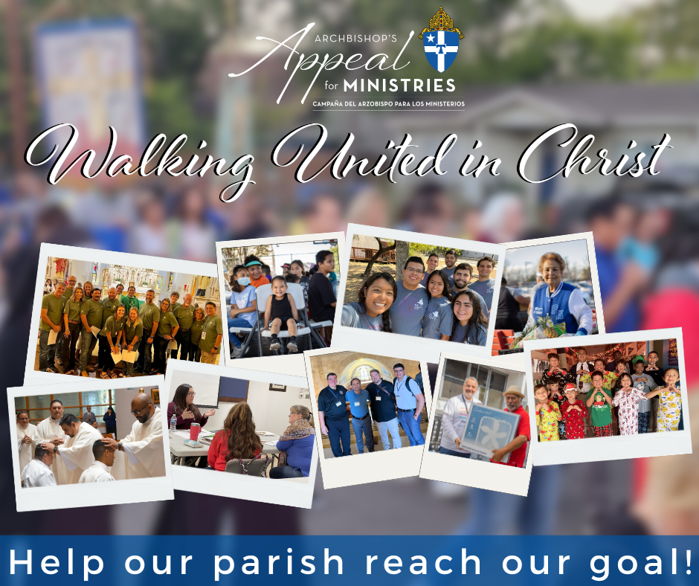
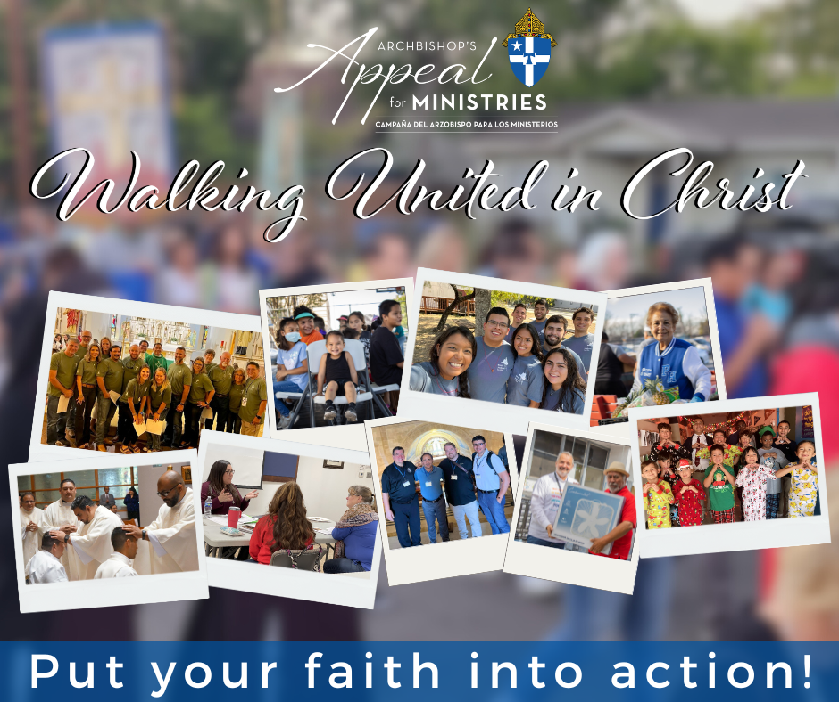

Possible Captions:
- The Archdiocese of San Antonio is made up of so many beautiful people and the Archbishop’s Appeal for Ministries is an opportunity to give back to all the great people that make up our Archdiocese! Start Walking United in Christ by setting up your gift today😄
Set up your gift online: https://archsa.org/aafm_giveasa
#AAFM #WalkingUnitedinChrist #putyourfaithintoaction #giveback

- Have your sent in your gift for the 2024 Archbishop’s Appeal for Ministries yet? Don’t worry, it’s never too late to start your giving👏
Help our parish reach our goal by setting up your gift today💙
Set up your gift online: https://archsa.org/aafm_giveasa
#AAFM #WalkingUnitedinChrist #putyourfaithintoaction #giveback

- Your gift to the Archbishop’s Appeal for Ministries supports all these people and so many more! Together we can make a difference in not only our community, but in the whole Archdiocese of San Antonio🤝💙
Set up your gift online: https://archsa.org/aafm_giveasa
#AAFM #WalkingUnitedinChrist #putyourfaithintoaction #giveback

More options below

Possible Captions:
- We have a goal we need your help to meet! Anything helps, we appreciate all your efforts😄
Set up your gift today: https://archsa.org/aafm_giveasa
#AAFM #WalkingUnitedinChrist #putyourfaithintoaction #giveback

- We couldn’t do anything without the support of our amazing parishioners! We are so grateful for all that your do for our parish💙 We pray that you will continue to give all your awesome support toward the 2024 Archbishop’s Appeal for Ministries!
Set up your gift today: https://archsa.org/aafm_giveasa
#AAFM #WalkingUnitedinChrist #putyourfaithintoaction #giveback

- There are so many ways to put your faith into action, but the easiest way is to make a gift to the Archbishop’s Appeal for Ministries! The Archbishop’s Appeal gives back to so many ministries in the Archdiocese of San Antonio so they can continue to do great things and help people in need🤝 Start Walking United in Christ today by setting up your gift to the Archbishop’s Appeal for Ministries!
Set up your gift today: https://archsa.org/aafm_giveasa
#AAFM #WalkingUnitedinChrist #putyourfaithintoaction #giveback

