- Access Paylocity > Recruiting (left navigation menu)
- Once on Recruiting page, click on Create New Job

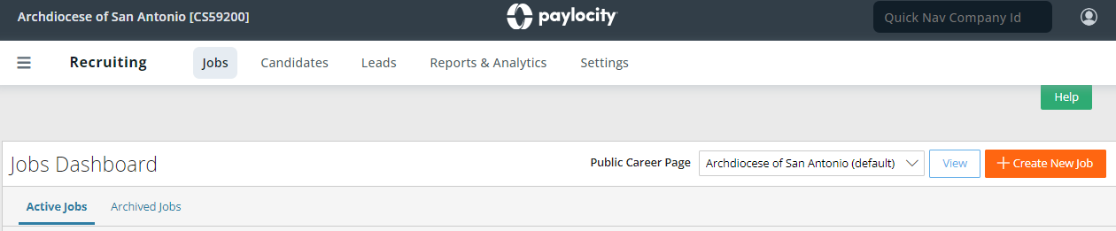

- RECRUITING > CREATE NEW JOB page will display the following:
- From dropdown, choose your parish/school name.
- Choose from the “Position Template” to view available templates.
- Work Location – Leave as “None”
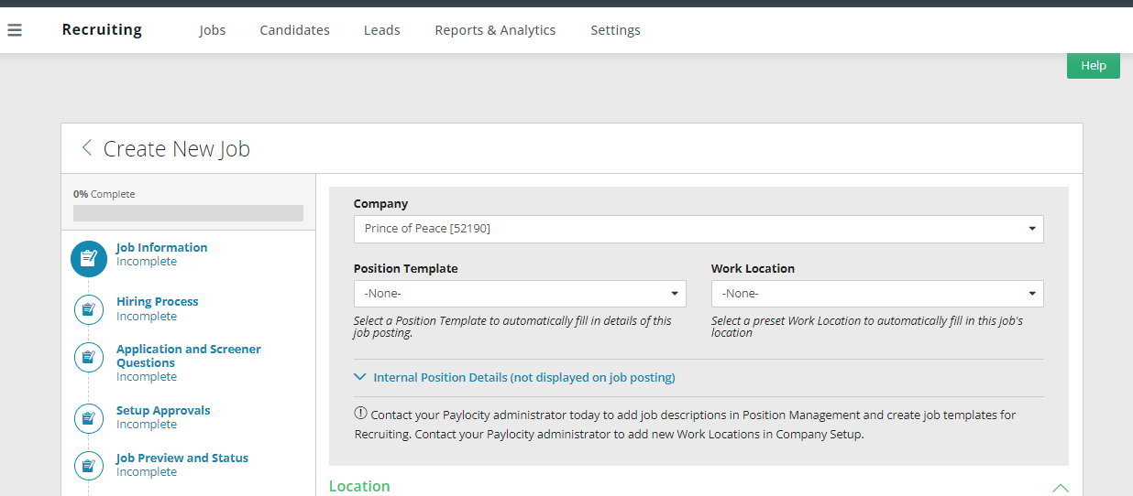

- If you do not see the name of the job description, immediately send an email to HR@archsa.org as we should have in our master files. We continue to work on loading all our templates into the position templates.
- Do not choose internal posting, ALL job postings are required to be EXTERNAL.
- Do not choose work location.

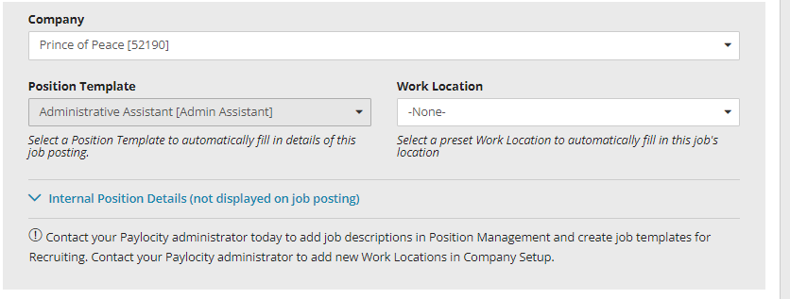

- LOCATION – Complete ALL data fields in this section other than those shown with a
- Is this job remote? Leave “No”
- Location Name – Your parish or school name. i.e St. Joseph - Nixon
- Metro City – Use same information used in Location name.
- Address, City, State, Zip Code
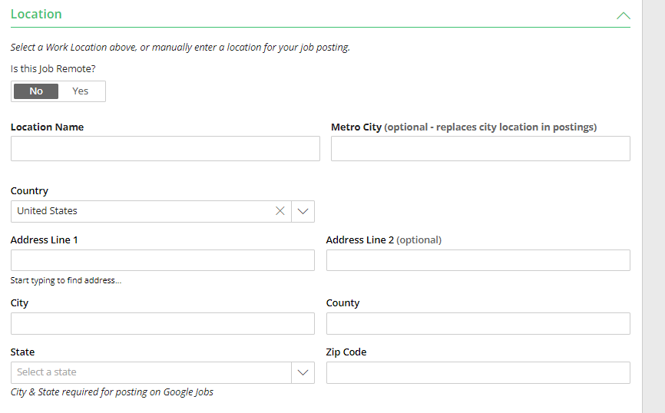

- DESCRIPTION AND REQUIREMENTS:
- Position Templates will automatically add information into Job Title, Job Description and Requirements. Review and amend, only if need.
- Position information provided by HR can be copied/pasted into these sections.
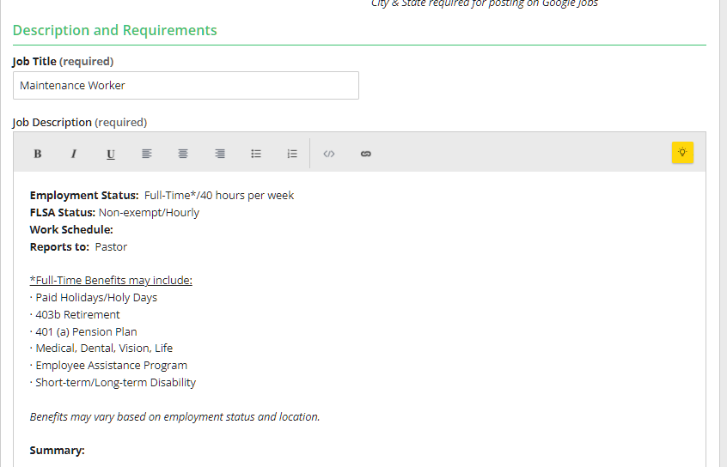

- Immediately underneath the Job Description header, add one of the following as appropriate: {required fields] Edit red font information as appropriate.

Employment Status: ex: Full-Time*
FLSA Status: ex: Non-Exempt/Hourly OR Exempt/Salaried
Schedule ex: Monday – Friday 9 am – 6pm
40 hours per week
Reports to: ex: Pastor

- In addition, need to also add the following:
Full-time positions (30-40 hours), should always reflect the following:

*Full-Time Benefits should include:
(Benefits may vary by location)
- Paid Holidays/Holy Days
- 403b Retirement
- 401 (a) Pension Plan
- Medical, Dental, Vision, Life
- Employee Assistance Program
- Short-term/Long-term Disability

Part-time positions (20-29 hours) :
(Reminder- part-time positions are never exempt/salaried)

Part-time Benefits may include:
(Benefits may vary by location)

- Paid Holidays/Holy Days
- 403b Retirement
- Employee Assistance Program

Part-time position (Less than 20 hours ONLY) :
(Reminder- part-time positions are never exempt/salaried)

Benefits may include:
(Benefits may vary by location)

- 403b Retirement
- Employee Assistance Program

- JOB REQUIREMENTS:
  - Should include the following details in this screenshot. Remember to add other details that may be applicable .
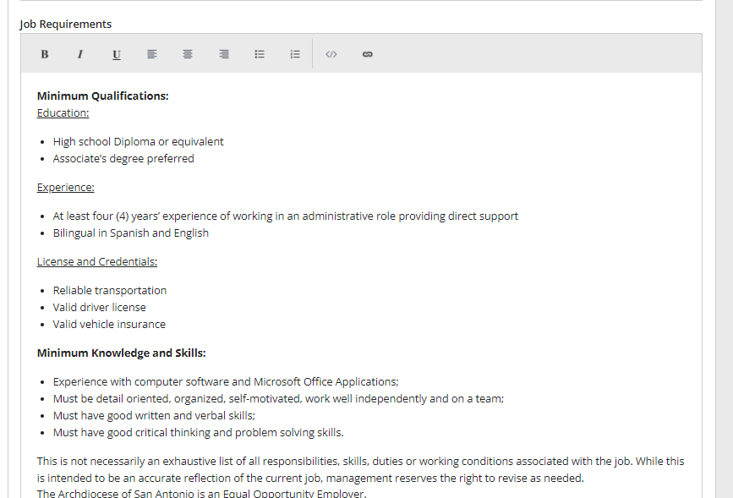
  - At the VERY bottom of EVERY Job Requirements section add the following text:
This is not necessarily an exhaustive list of all responsibilities, skills, duties or working conditions associated with the job. While this is intended to be an accurate reflection of the current job, management reserves the right to revise as needed. The Archdiocese of San Antonio is an Equal Opportunity Employer.

- JOB INFORMATION and SALARY INFORMATION:
    - Job ID, Hiring Department, Job Type, Include Salary in Public Posting– DO NOT add
information in these fields.
  - Salary Description – ADD the salary for the position being posted. Ex: Hourly (ie. $15-17) or Salaried (i.e. $38-$42k) for the position. Salary ranges must be aligned w/like positions and comparable to existing location pay. Contact your HR Business Partner for assistance on salary ranges BEFORE making a job offer. Salary range information WILL NOT display on the job posting, this is strictly for internal purposes only.
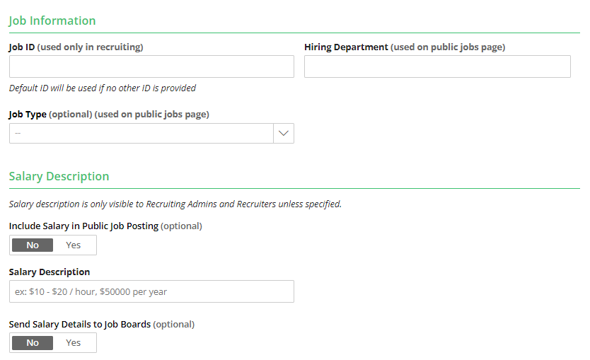

- JOB SLOTS – no information needed.
- CLICK – NEXT – HIRING PROCESS
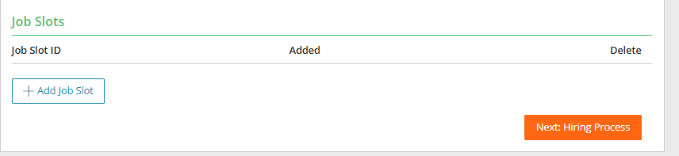

HIRING WORKFLOW:
- DO NOT change Selected Workflow – Automatically defaults to ArchSA Workflow Update.
- HIRING TEAM: Recruiter –Normally Bookkeeper name. Hiring Manager – Name of Pastor/Hiring Manager - Team Member – leave blank given if you put your name here you cannot see resumes, nor move candidates through the process. Note: You only need name in one place, not multiple sections.
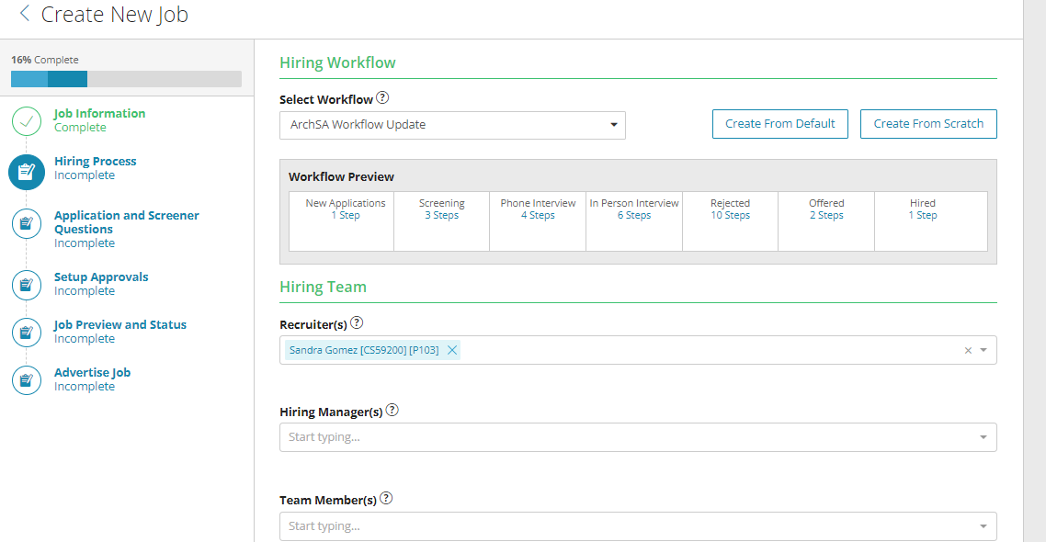
- Then Click Next: Application and Screener Questions
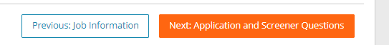
12. Application (Screener) – DO NOT change.
13. Add Screener to Application – this is REQUIRED although it indicates optional.
a. Parishes – SELECT Copy of Archdiocese Screeners
b. Schools – SELECT appropriate school screener.
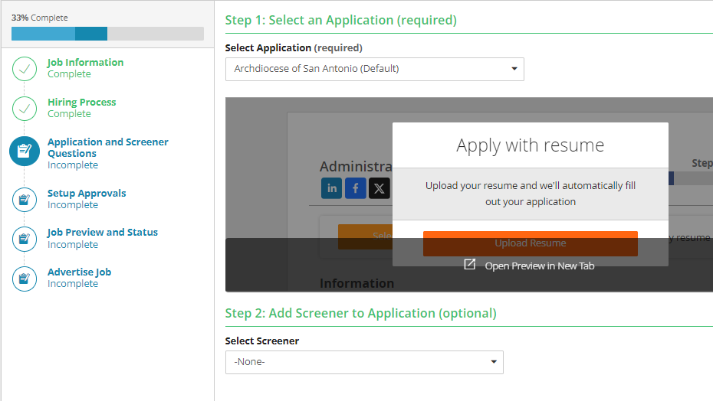

14. AUTOMATICALLY REJECT CANDIDATE – MUST SELECT
a. Move Rejected candidates to: Rejected Not Qualified
b. Rejection Reason – Screener Failed
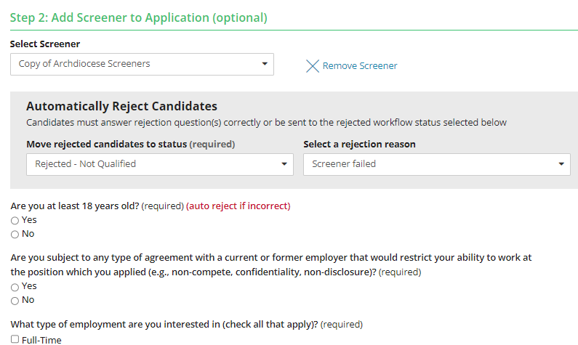
15. CLICK: Next: Setup Approvals 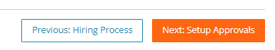
16. JOB REQUISITION APPROVALS – DO NOT select from dropdown, just click on
NEXT JOB: PREVIEW & STATUS button
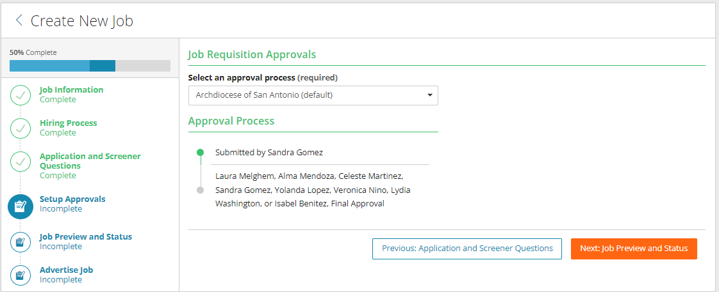

17. Click - SUBMJT JOB FOR APPROVAL BUTTON (Do not change anything else on this screen)
a. Submit for Approval – will send to HR team to review, approve/edit and post.
b. Save As Draft- You can click on this to save, however, it will not send to HR. Once you modify Draft, be sure to Submit for Approval.
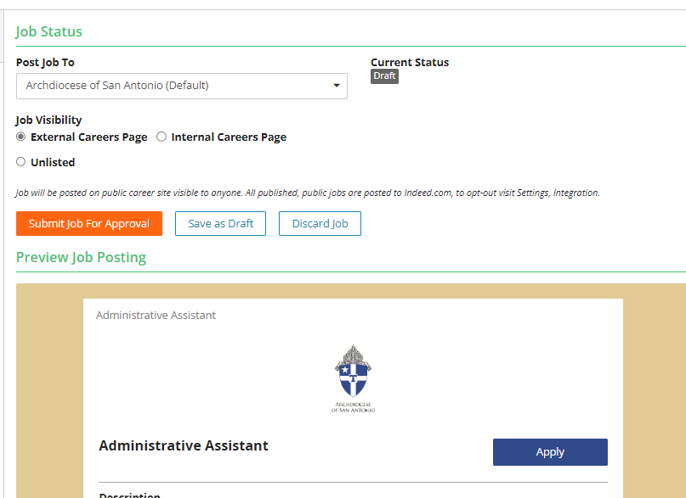

Questions regarding this document may be referred to HR@archsa.org. Thank you!!

Archdiocese of San Antonio
Human Resources Team
HR@archsa.org

